Registration Form
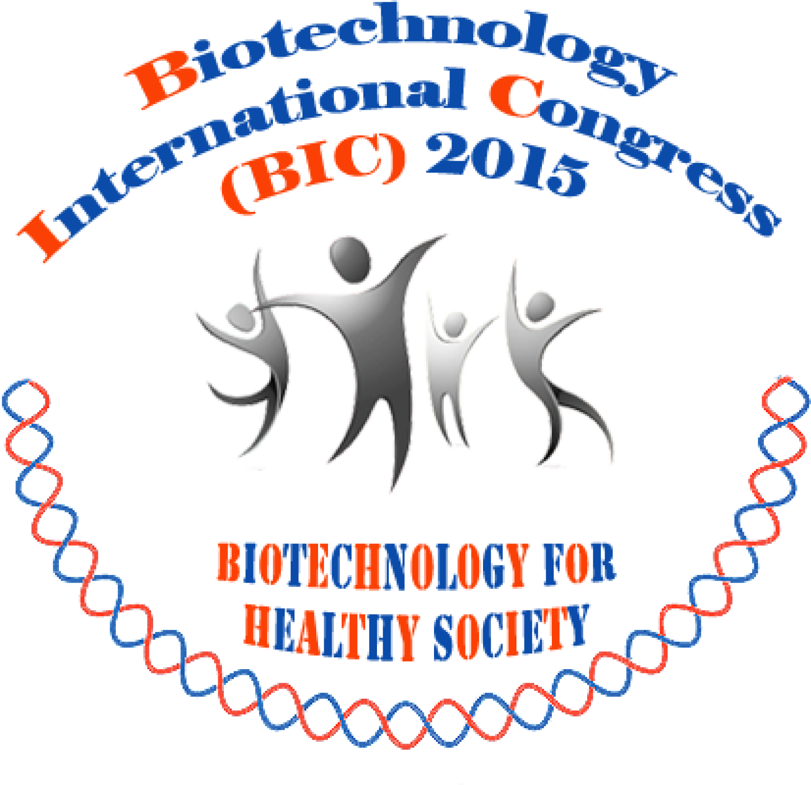 | Biotechnology International Congress (BIC) 2015  “Biotechnology for Healthy Society”  September 9-11, 2015 at BITEC, Bangkok, Thailand
Name (English) |  | For example Prof.Dr. Tsb I. Congress
Gender |  | [□] Male [□] Female
Country (residence)
Address (as in the receipt)

Mobile Phone
E-mail |  | It can be more than 1 address.
Expertise/Field of interest
Working experience (in brief)
Choose sessions for the conference |  | [□] Biotechnology International Congress (BIC) 2015 “Biotechnology for Healthy Society”  [□] Jatrohpa Updates 2015  [□] TU-TSB special session on biomass utilization
Type/Title of presentation  [□] oral  [□] poster  [□] Attending participant  Type of submission  [□] abstract  [□] full paper |  | Type your paper title here.
Registration Fees |  | [□] 4,500 Baht (non-TSB member)*  [□] 3,500 Baht (TSB member)  [□] 2,500 Baht (Student)**  [□] 2,000 Baht (Attending participant)  * สิทธิพิเศษในการเป็นสมาชิกสมาคมเทคโนโลยีชีวภาพแห่งประเทศไทย ประเภทสามัญ-สมาชิตลอดชีพ  ** เมื่อลงทะเบียน กรุณาแสดงสำเนาบัตรนิสิต นักศึกษา ที่ไม่หมดอายุก่อน 9 กันยายน 2558
Importance:
- Please submit this registration form along with your full paper or abstract in word files (one presenter one paper only) to TSBforum@hotmail.com. The dead line is June 1, 2015. June 20, 2015
- The file names should be surname_registration.doc, surname _abstract.doc or surname_paper.doc.
- For the payment, please transfer money to this account by July 31, 2015 and email your bank transfer slip to TSBforum@hotmail.com or fax to 66-2-644-8079.
Bank: Siam Commercial Bank Public Company Limited
Account name: Thai Society for Biotechnology
Account number: 026-2-96429-4
Branch: Ramathibodi Swift code: SICOTHBK
-------------------------------------------------------------------

